Umbra

📘 Definition
# Source: AI Source: Provided by: [Data Path: Persons Table -> ID Column: 1, Name_En Column: Motasem Essam] -> From: [ChatGPT] on [5/2/2026]
The Umbra is the darkest and innermost part of a shadow, where all light from the source is completely blocked by an object.
It is the area of total darkness in a shadow.

🌑 How umbra forms
# Source: AI Source: Provided by: [Data Path: Persons Table -> ID Column: 1, Name_En Column: Motasem Essam] -> From: [ChatGPT] on [5/2/2026]
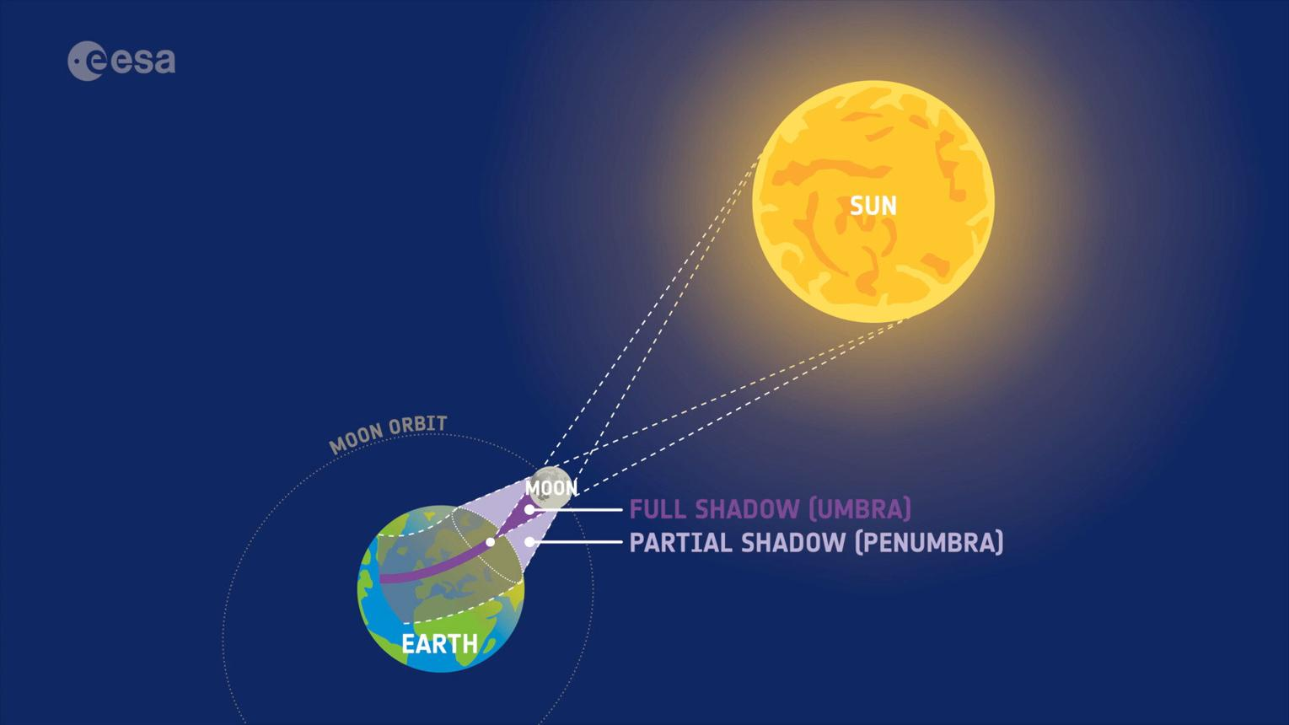
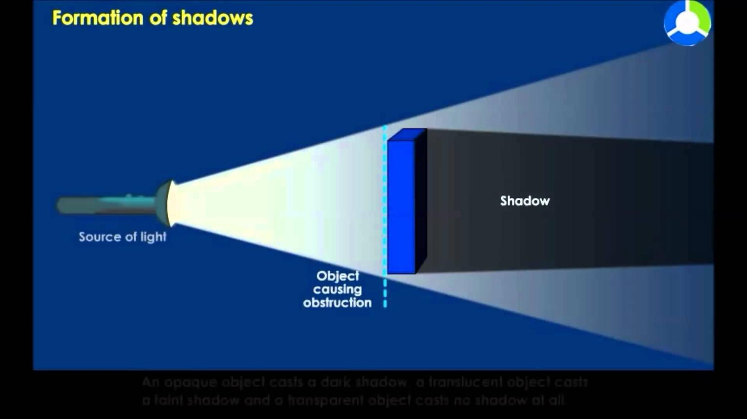
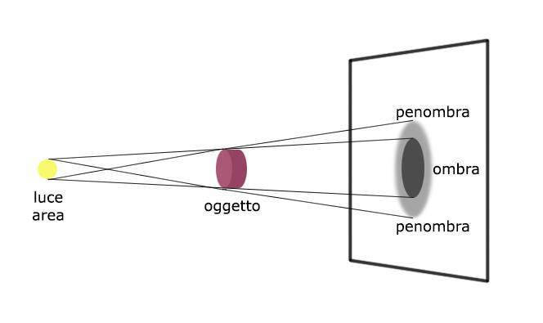
- Light is completely blocked
- No direct light reaches this region
- Appears as the deepest dark part of a shadow

🧠 Simple example
# Source: AI Source: Provided by: [Data Path: Persons Table -> ID Column: 1, Name_En Column: Motasem Essam] -> From: [ChatGPT] on [5/2/2026]
Think of:
- 🌘 A solar eclipse → the darkest center area is the umbra
- ☀️ Your shadow → the darkest middle part closest to the object

🌍 Umbra in real life
# Source: AI Source: Provided by: [Data Path: Persons Table -> ID Column: 1, Name_En Column: Motasem Essam] -> From: [ChatGPT] on [5/2/2026]
- During a solar eclipse, people inside the umbra see a total eclipse
- In everyday shadows, it is the sharp darkest core area

⚙️ Key features
# Source: AI Source: Provided by: [Data Path: Persons Table -> ID Column: 1, Name_En Column: Motasem Essam] -> From: [ChatGPT] on [5/2/2026]
- 🌑 Completely dark region
- 📍 Found at the center of a shadow
- ☀️ No light reaches this area at all
- 🎯 Smallest but darkest part of a shadow

🚀 In short:
# Source: AI Source: Provided by: [Data Path: Persons Table -> ID Column: 1, Name_En Column: Motasem Essam] -> From: [ChatGPT] on [5/2/2026]
Umbra = the darkest part of a shadow where all light is completely blocked.

